-실행 준비 작업 pdf 참고 후 ( IP설정을 위해 Nat에서 bridge로 바꿔줘야 가능)

#!/usr/bin/env python

import rospy

from msg_send.msg import my_msg

from std_msgs.msg import String

done = False

def call_back(data):

msg = data.data

if ('Jeong Soo-Rim' in msg):

print(msg)

else:

print("waiting")

done = True

rospy.init_node('remote_student', anonymous=True)

pub=rospy.Publisher('msg_to_xycar', my_msg, queue_size=1)

rospy.Subscriber('msg_from_xycar', String, call_back)

rate = rospy.Rate(0.5)

msg = my_msg()

msg.first_name = "Soo-Rim"

msg.last_name = "Jeong"

msg.age = 15

msg.score = 100

msg.id_number = 12345678

msg.phone_number = "010-0000-0000"

while not rospy.is_shutdown() and not done:

pub.publish(msg)

print("sending message...")

rate.sleep()

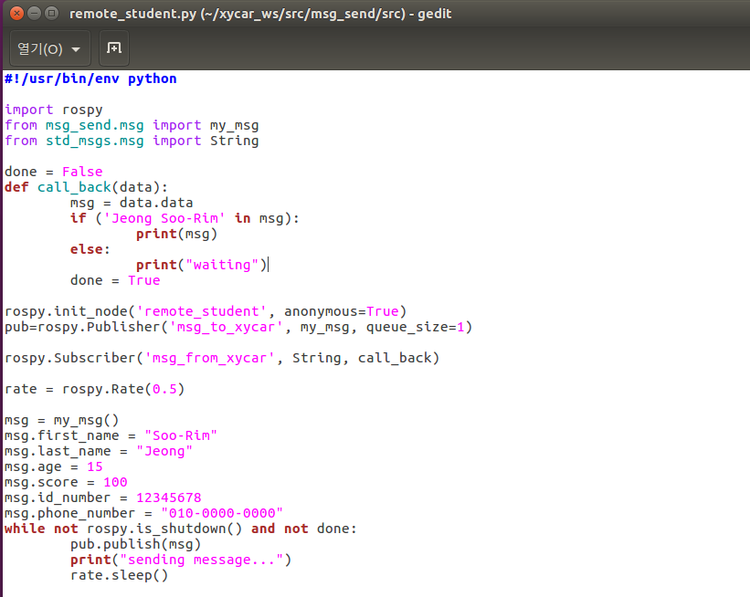

chmod +x *.py

rosrun msg_send remote_student.py

